**CSS Box Model**

All HTML elements can be considered as boxes an consists of:

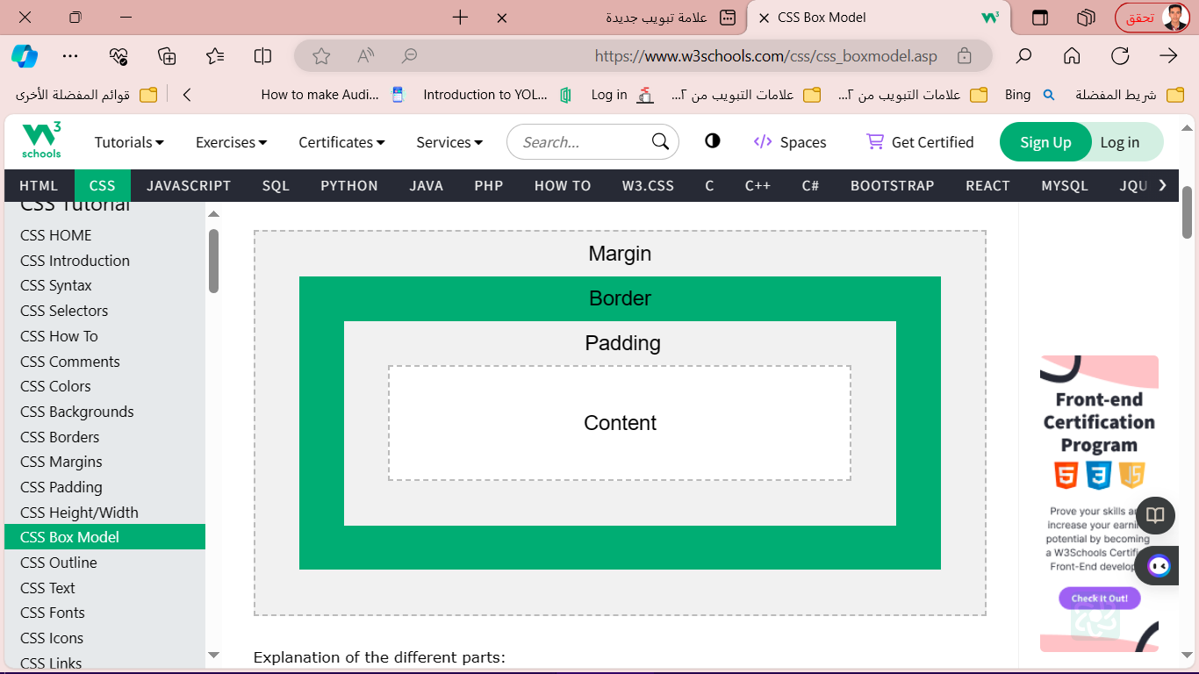

* **CSS Outline**

An outline is a line drawn outside the element's border.

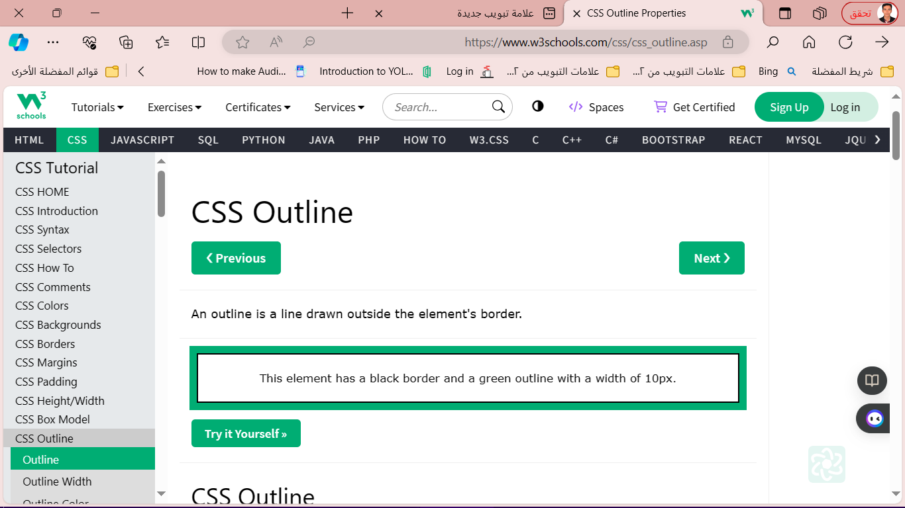

<style>

CSS has the following outline properties:

* outline-style
* outline-color
* outline-width
* outline-offset
* outline

p {

border: 2px solid black;

outline: #4CAF50 solid 10px;

margin: auto;

padding: 20px;

text-align: center;

}

</style>

<h2>CSS Outline</h2>

<p>This element has a 2px black border and a green outline with a width of 10px.</p>

* **CSS Outline Style**

p.dotted {outline-style: dotted;}  
p.dashed {outline-style: dashed;}  
p.solid {outline-style: solid;}  
p.double {outline-style: double;}  
p.groove {outline-style: groove;}  
p.ridge {outline-style: ridge;}  
p.inset {outline-style: inset;}  
p.outset {outline-style: outset;}

can have one of the following values:

* dotted - Defines a dotted outline
* dashed - Defines a dashed outline
* solid - Defines a solid outline
* double - Defines a double outline
* groove - Defines a 3D grooved outline
* ridge - Defines a 3D ridged outline
* 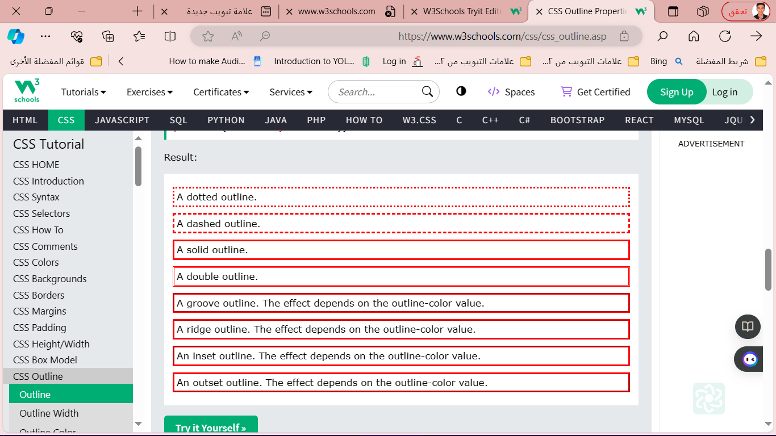inset - Defines a 3D inset outline
* outset - Defines a 3D outset outline
* none - Defines no outline
* hidden - Defines a hidden outline
* **CSS Outline Width**

can have one of the following values:

* thin (typically 1px)
* medium (typically 3px)
* thick (typically 5px)
* A specific size (in px, pt, cm, em, etc)

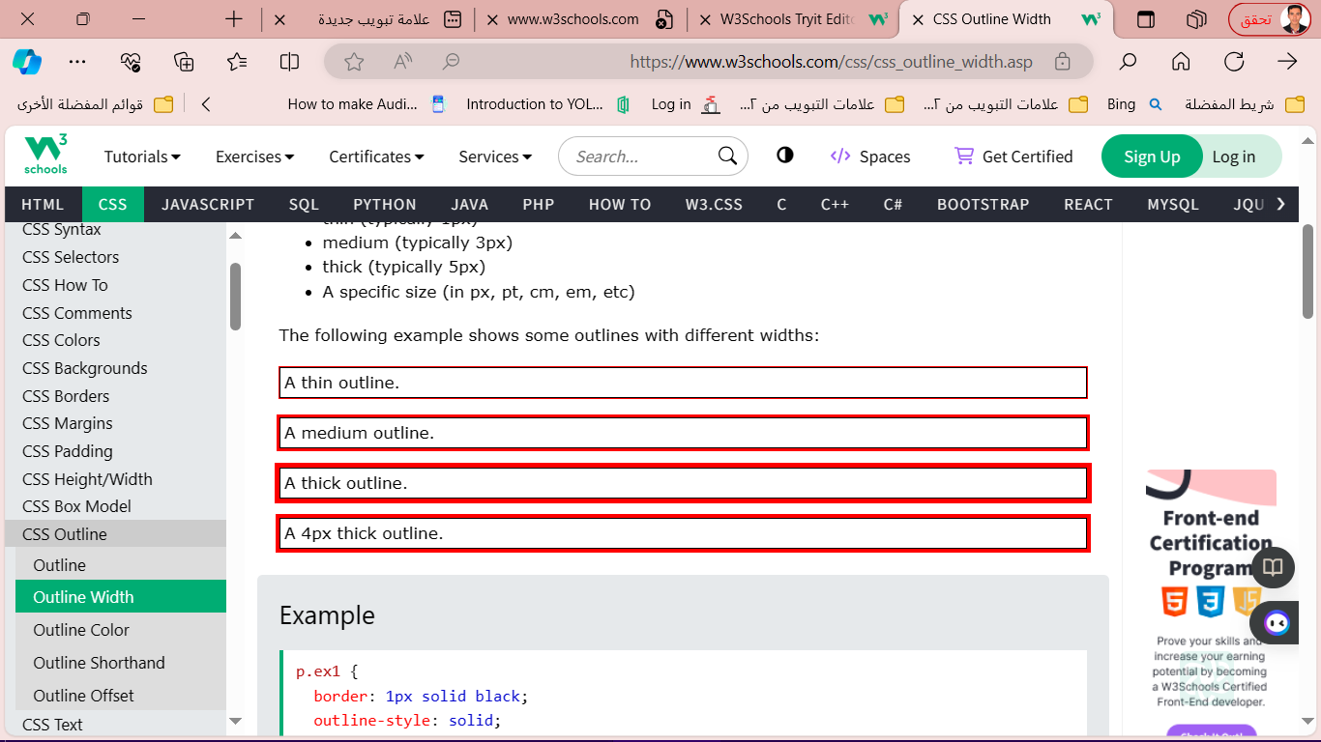

p.ex1 {  
  border: 1px solid black;  
  outline-style: solid;  
  outline-color: red;  
  outline-width: thin;  
}  
  
p.ex2 {  
  border: 1px solid black;  
  outline-style: solid;  
  outline-color: red;  
  outline-width: medium;  
}  
  
p.ex3 {  
  border: 1px solid black;  
  outline-style: solid;  
  outline-color: red;  
  outline-width: thick;  
}  
  
p.ex4 {  
  border: 1px solid black;  
  outline-style: solid;  
  outline-color: red;  
  outline-width: 4px;  
}

**in body:**

**<p class="ex1">A thin outline.</p>**

**<p class="ex2">A medium outline.</p>**

**<p class="ex3">A thick outline.</p>**

**<p class="ex4">A 4px thick outline.</p>**

* **CSS Outline Color:** The outline-color property is used to set the color of the outline.

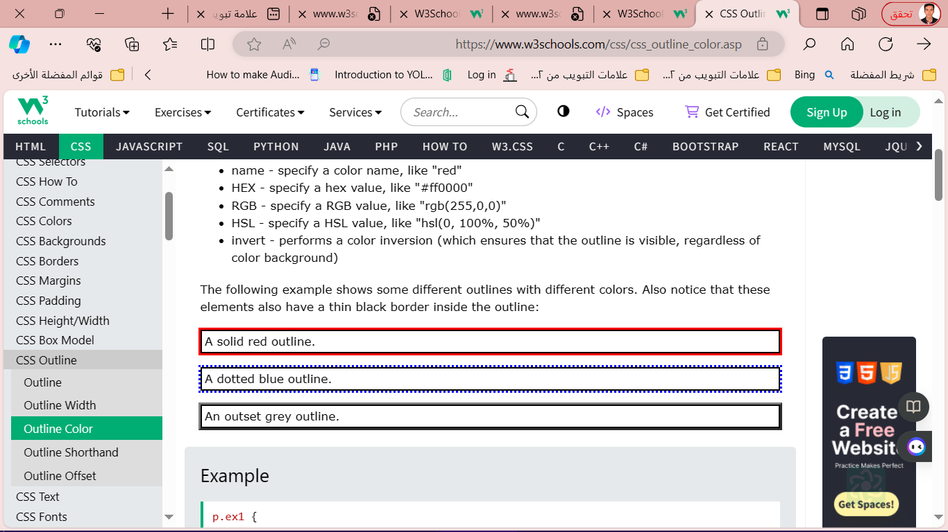

p.ex1 {  
  border: 2px solid black;  
  outline-style: solid;  
  outline-color: red;  
}  
  
p.ex2 {  
  border: 2px solid black;  
  outline-style: dotted;  
  outline-color: blue;  
}  
  
p.ex3 {  
  border: 2px solid black;  
  outline-style: outset;  
  outline-color: grey;  
}

* **CSS Outline - Shorthand property:** The outline property is a shorthand property for setting the following individual outline properties:
* outline-width
* outline-style (required)
* outline-color

p.ex1 {outline: dashed;}  
p.ex2 {outline: dotted red;}  
p.ex3 {outline: 5px solid yellow;}

p.ex4 {outline: thick ridge pink;}

* **CSS Outline Offse:**

خاصية outline-offset تضيف مسافة بين الخط الخارجي (outline) وحافة العنصر أو حدوده. المسافة بين العنصر والخط الخارجي شفافة

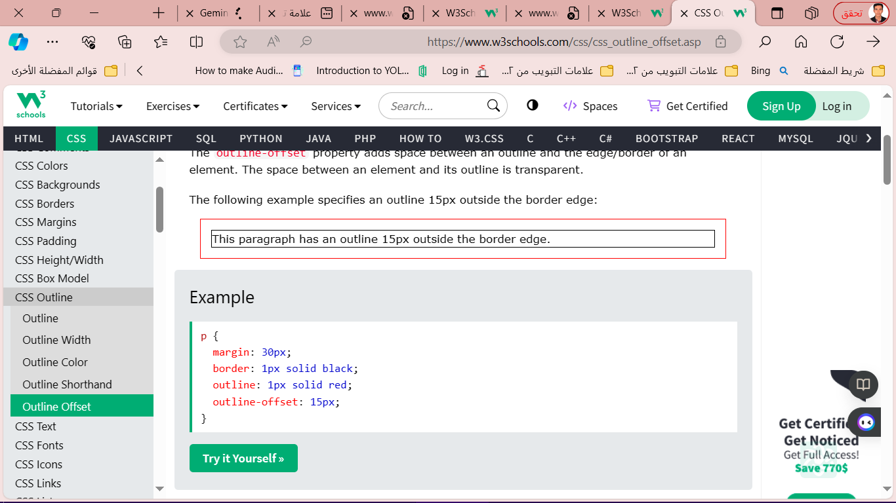

p {  
  margin: 30px;  
  border: 1px solid black;  
  outline: 1px solid red;  
  outline-offset: 15px;  
}

* 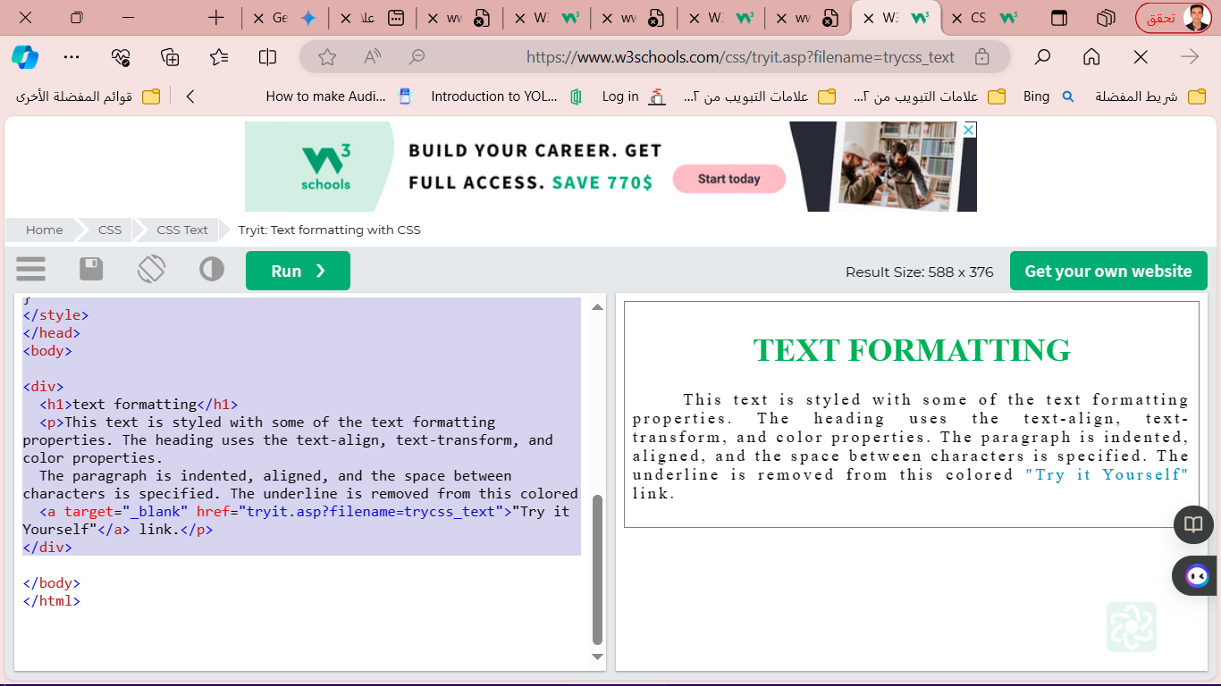**CSS Text**

CSS has a lot of properties for

formatting text.

* **Text Color**

The color property is used to set the color of the text

<style>

div {

border: 1px solid gray;

padding: 8px;

}

h1 {

text-align: center;

text-transform: uppercase;

color: #4CAF50;

}

p {

text-indent: 50px;

text-align: justify;

letter-spacing: 3px;

}

a {

text-decoration: none;

color: #008CBA;

}

</style>

<div>

<h1>text formatting</h1>

<p>This text is styled with some of the text formatting properties. The heading uses the text-align, text-transform, and color properties.

The paragraph is indented, aligned, and the space between characters is specified. The underline is removed from this colored

<a target="_blank" href="tryit.asp?filename=trycss_text">"Try it Yourself"</a> link.</p>

</div>

* **Text Alignment and Text Direction**
* خاصية text-align تُستخدم للتحكم في المحاذاة الأفقية للنص.
* text-align
* text-align-last
* direction
* unicode-bidi
* vertical-align

A text can be left or right aligned, centered,

or justified.

**Example**

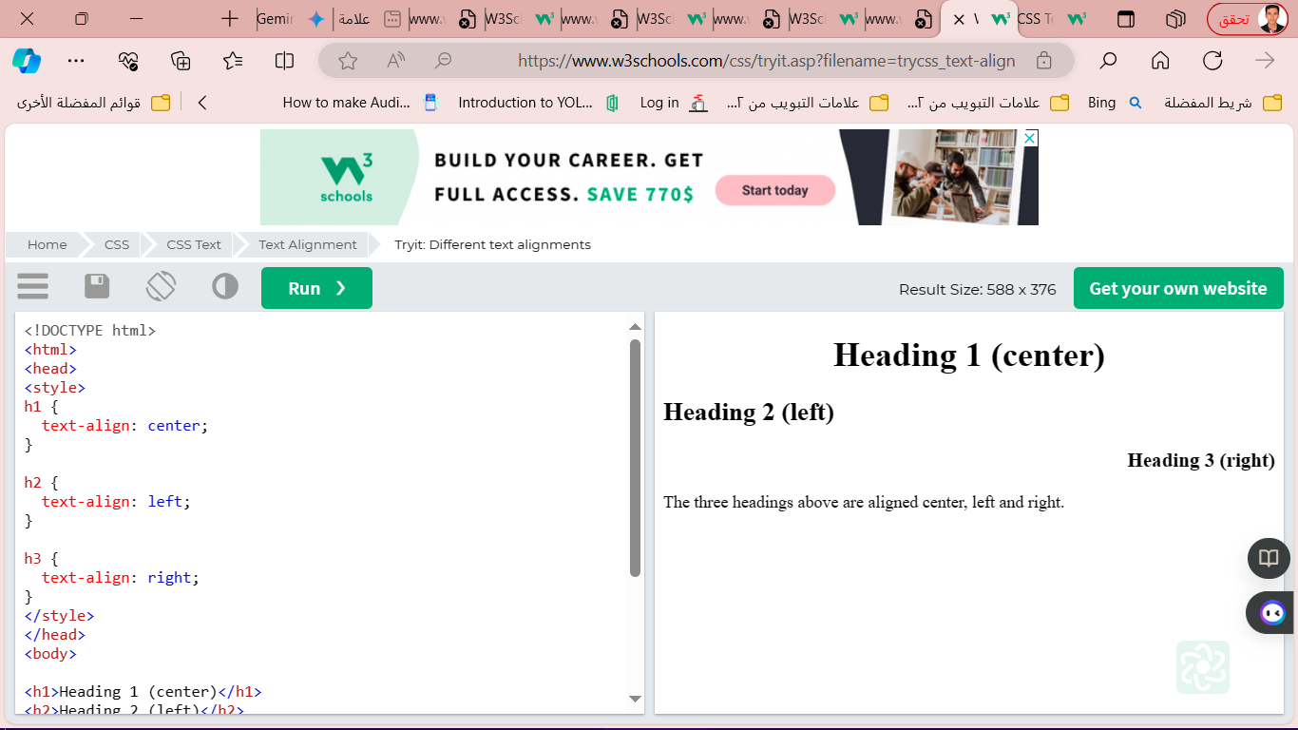h1 {  
  text-align: center;  
}  
  
h2 {  
  text-align: left;  
}  
  
h3 {  
  text-align: right;  
}

**The text-align-last property specifies how to align the last line of a text.**

**Example**

Align the last line of text in three <p> elements:

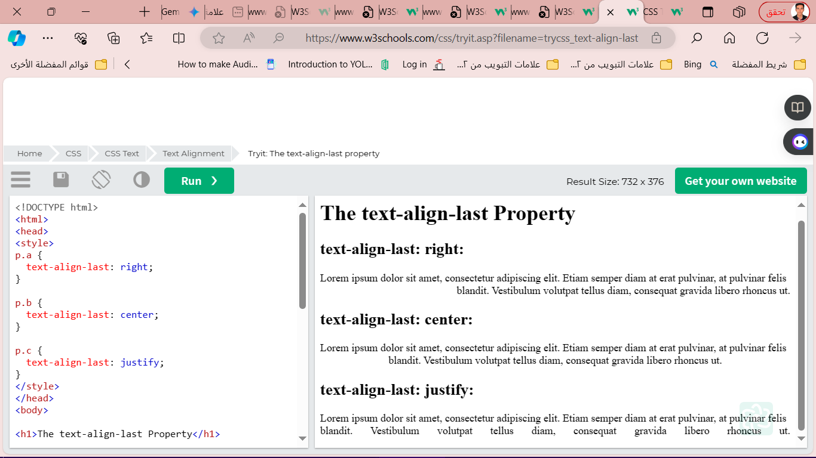p.a {  
  text-align-last: right;  
}  
  
p.b {  
  text-align-last: center;  
}  
  
p.c {  
  text-align-last: justify;  
}

**The direction and unicode-bidi properties can be used to change the text direction of an element:**

**Example**

p {  
  direction: rtl;  
  unicode-bidi: bidi-override;  
}

**The vertical-align property sets the vertical alignment of an element.**

**Example**

Set the vertical alignment of an image in a text:

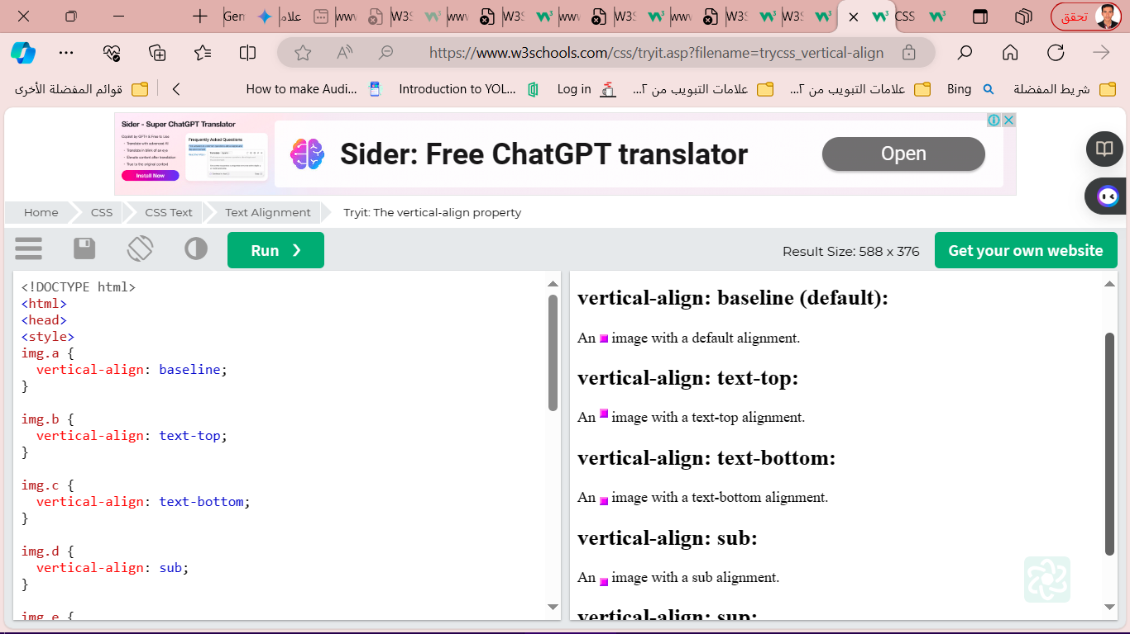img.a {  
  vertical-align: baseline;  
}  
  
img.b {  
  vertical-align: text-top;  
}  
  
img.c {  
  vertical-align: text-bottom;  
}  
  
img.d {  
  vertical-align: sub;  
}  
  
img.e {  
  vertical-align: super;  
}

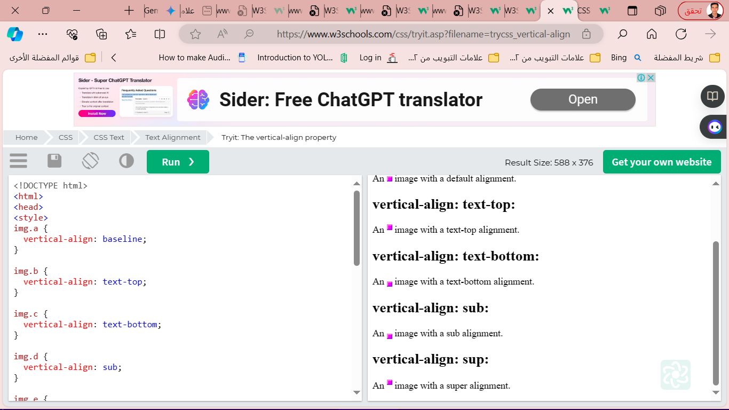

* **CSS Text Decoration**
* text-decoration-line
* text-decoration-color
* text-decoration-style
* text-decoration-thickness
* text-decoratio

**The text-decoration-line property is used**

**to add a decoration line to text.**

**Example**

h1 {  
  text-decoration-line: overline;  
}  
  
h2 {  
  text-decoration-line: line-through;  
}  
  
h3 {  
  text-decoration-line: underline;  
}  
  
p {  
  text-decoration-line: overline underline;  
}

**The text-decoration-color property is used to set the color of the decoration line.**

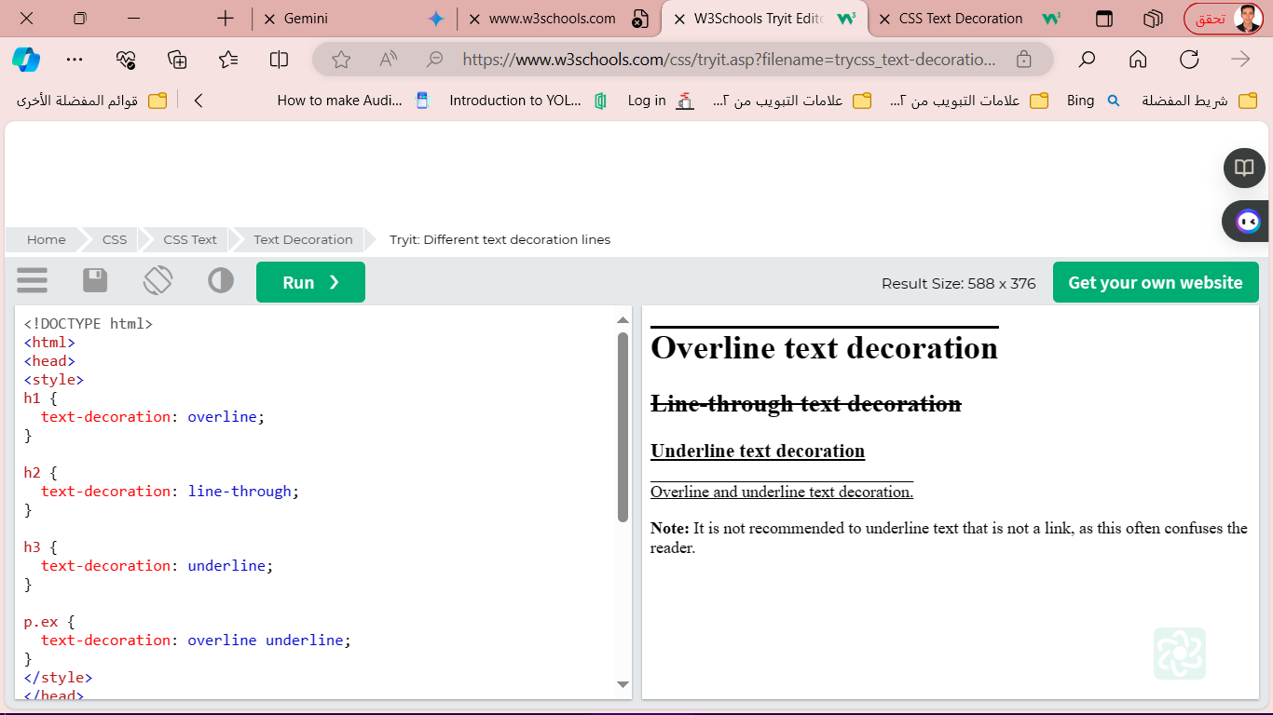

**Example**

h1 {  
  text-decoration-line: overline;  
  text-decoration-color: red;  
}  
  
h2 {  
  text-decoration-line: line-through;  
  text-decoration-color: blue;  
}  
  
h3 {  
  text-decoration-line: underline;  
  text-decoration-color: green;  
}  
  
p {  
  text-decoration-line: overline underline;  
  text-decoration-color: purple;  
}

**The text-decoration-style property is used to set the style of the decoration line.**

h1 {  
  text-decoration-line: underline;  
  text-decoration-style: solid;  
}  
h2 {  
  text-decoration-line: underline;  
  text-decoration-style: double;  
}  
h3 {  
  text-decoration-line: underline;  
  text-decoration-style: dotted;  
}  
p.ex1 {  
  text-decoration-line: underline;  
  text-decoration-style: dashed;  
}  
p.ex2 {  
  text-decoration-line: underline;  
  text-decoration-style: wavy;  
}  
p.ex3 {  
  text-decoration-line: underline;  
  text-decoration-color: red;  
  text-decoration-style: wavy;  
}

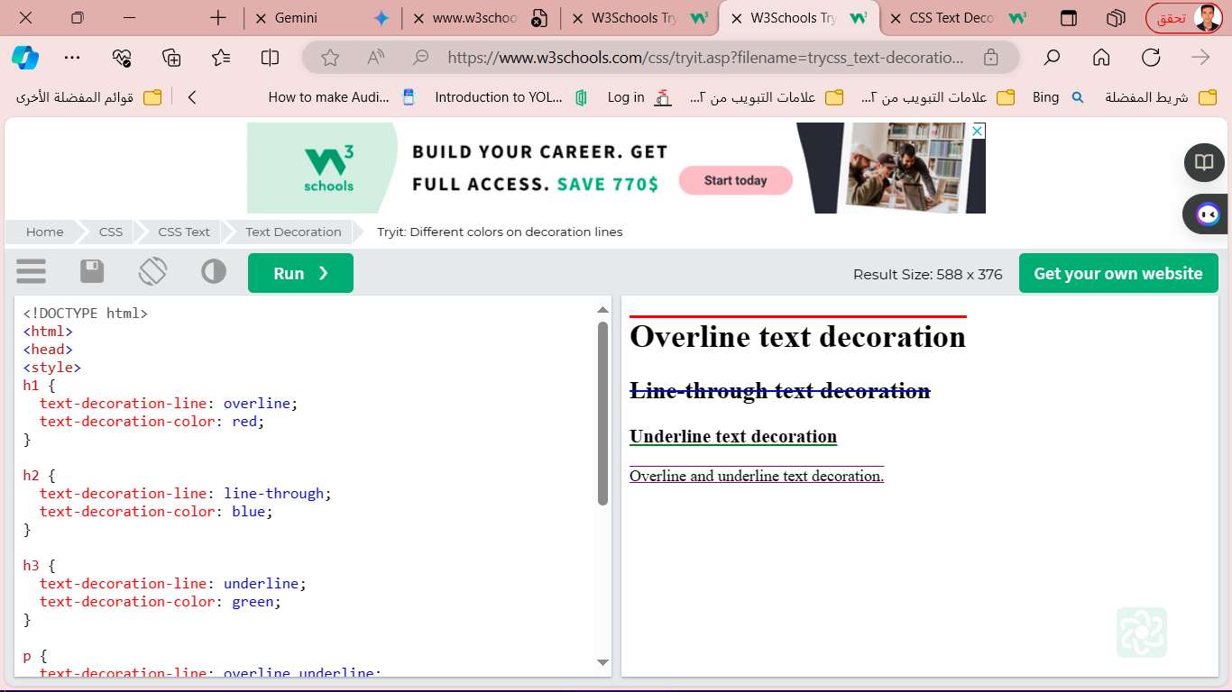

**The text-decoration-thickness property is used to set the thickness of the decoration line.**

**Example**

h1 {  
  text-decoration-line: underline;  
  text-decoration-thickness: auto;  
}  
h2 {  
  text-decoration-line: underline;  
  text-decoration-thickness: 5px;  
}  
h3 {  
  text-decoration-line: underline;  
  text-decoration-thickness: 25%;  
}  
p {  
  text-decoration-line: underline;  
  text-decoration-color: red;  
  text-decoration-style: double;  
  text-decoration-thickness: 5px;  
}

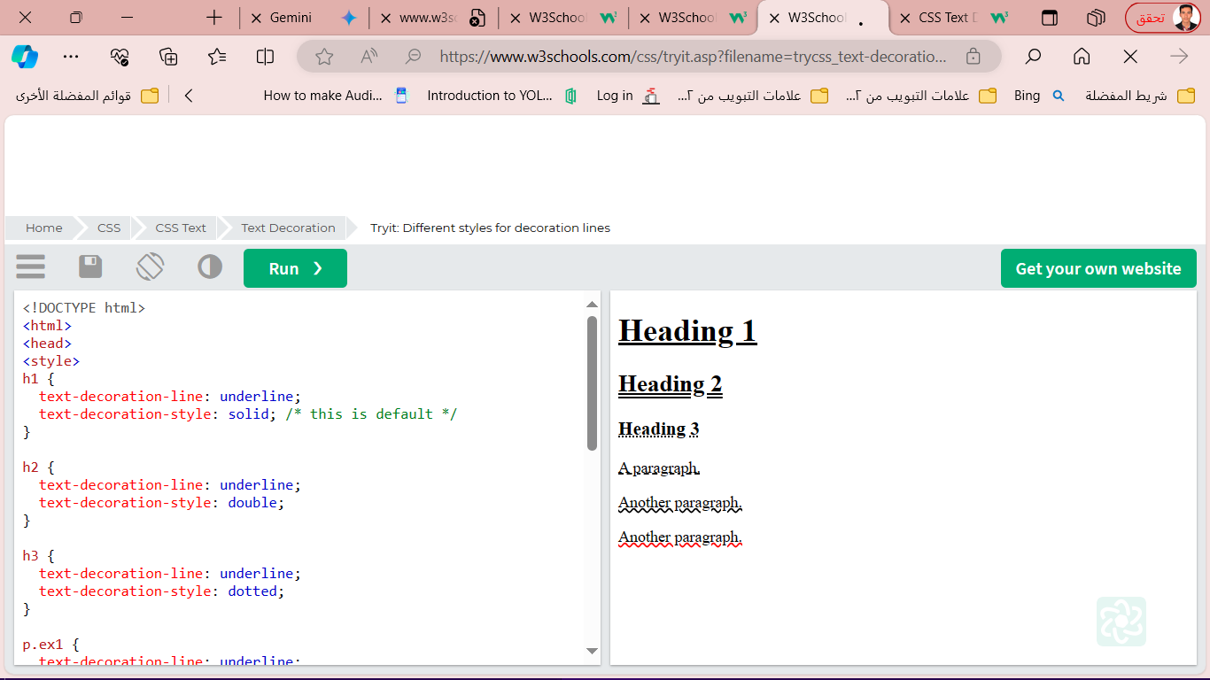

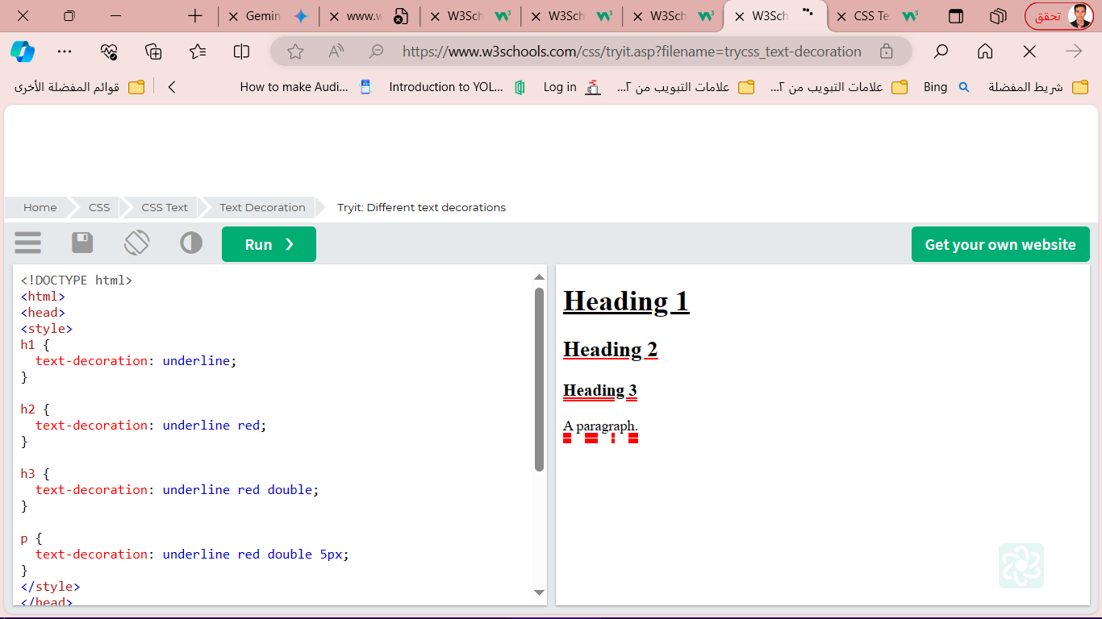**The text-decoration property is a shorthand property for:**

* text-decoration-line (required)
* text-decoration-color (optional)
* text-decoration-style (optional)
* text-decoration-thickness (optional)

**Example**

h1 {  
  text-decoration: underline;  
}  
h2 {  
  text-decoration: underline red;  
}  
h3 {  
  text-decoration: underline red double;  
}  
p {  
  text-decoration: underline red double 5px;  
}

* **CSS Text Transformation:**The text-transform property is used to specify uppercase and lowercase letters in a text.

**Example**

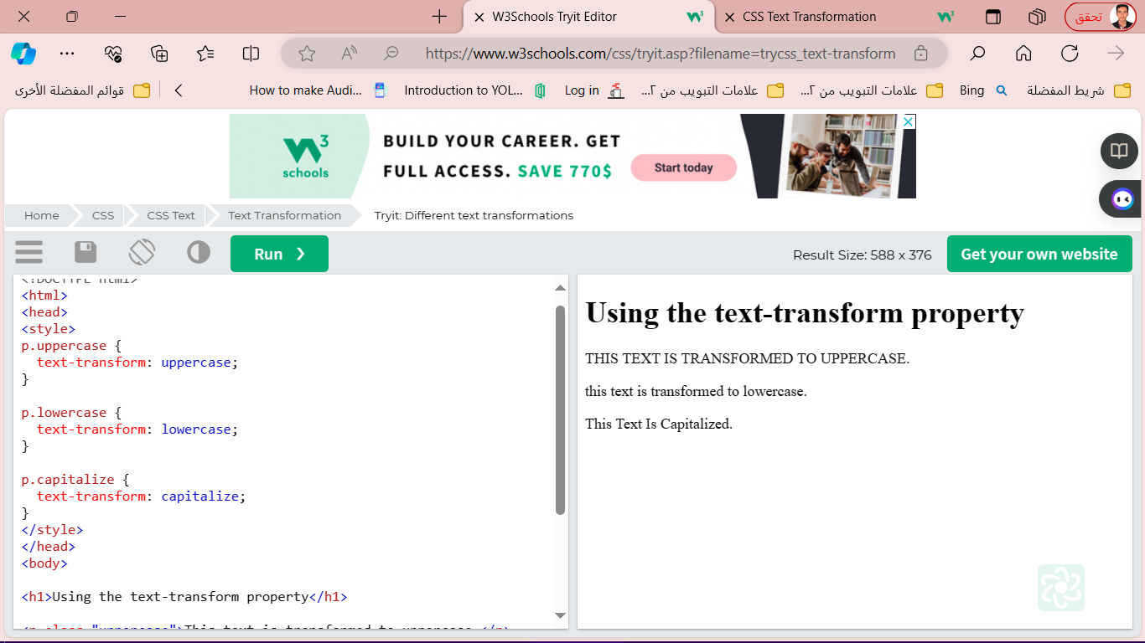p.uppercase {  
  text-transform: uppercase;  
}  
  
p.lowercase {  
  text-transform: lowercase;  
}  
  
p.capitalize {  
  text-transform: capitalize;  
}

* text-indent
* letter-spacing
* line-height
* word-spacing
* white-space

**- CSS Text** **Spacing**

* **CSS Text Shadow**

The text-shadow property adds shadow to text.

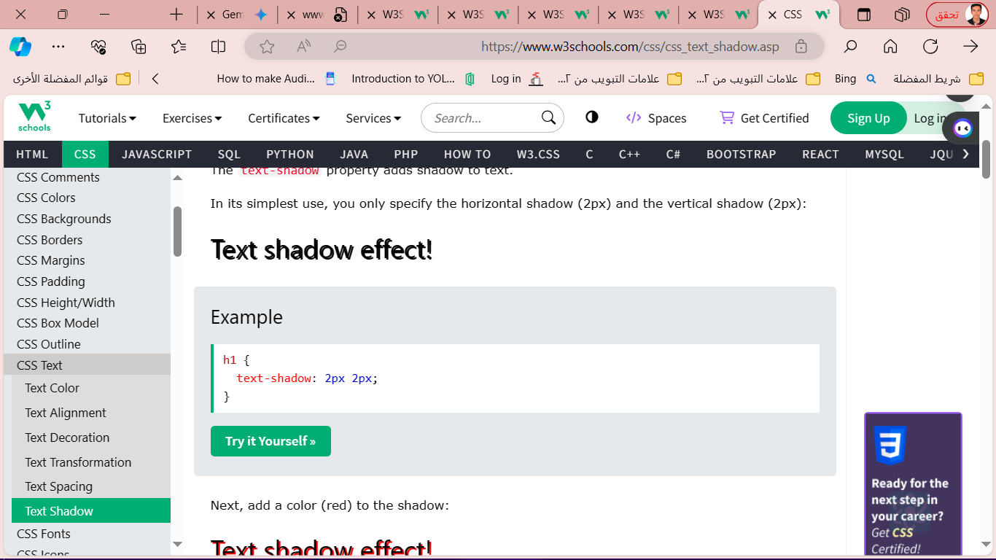**Example**

h1 {  
  text-shadow: 2px 2px;  
}

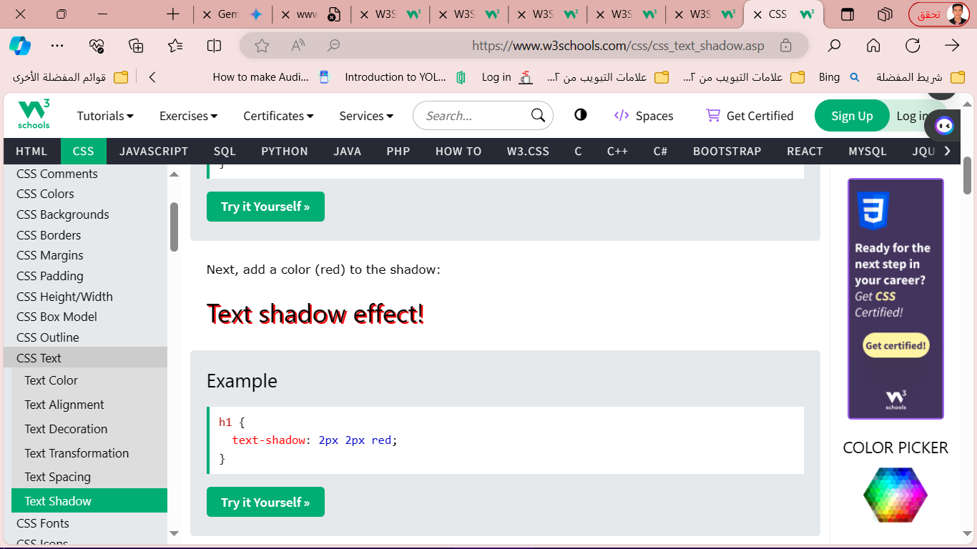**Example**

h1 {  
  text-shadow: 2px 2px red;  
}

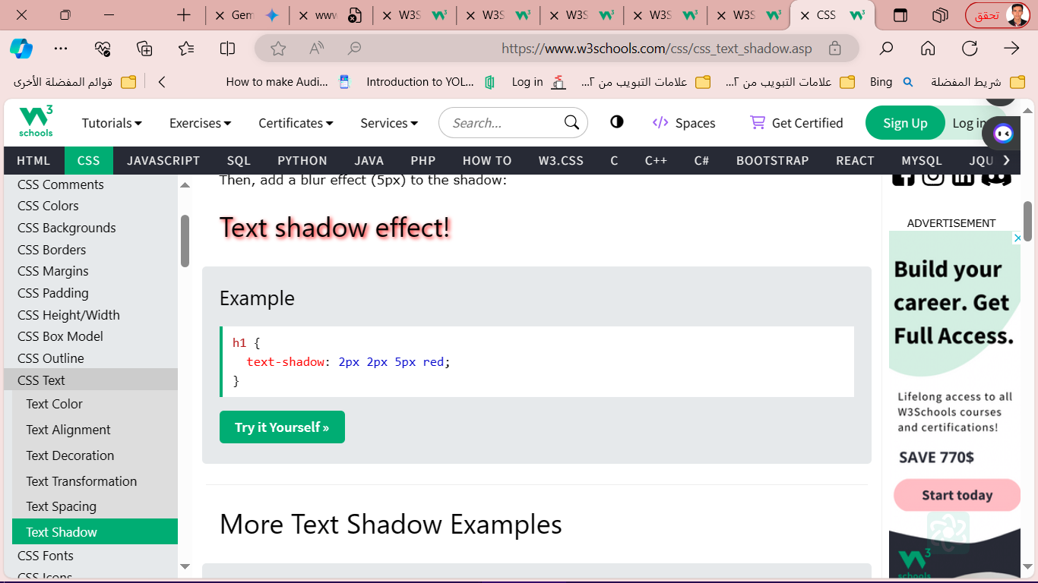**Example**

h1 {  
  text-shadow: 2px 2px 5px red;  
}